**First Time Homebuyer – Locker Enrollment Journey**

**Criteria: New Lead added to Total Expert.**

At any point along the journey, if the recipient creates a Locker, the journey will end.

**Cadence -** Email = Day 1, Day 5, Day 10, Day 16, Day 24, Day 30

Email: Day 1

Subject line: Get all the resources you need to buy a home in one app

**Get prepared for homeownership with your free [FinLocker]**

Hi [recipient-first-name]

Congratulations on taking the first step to getting financially prepared to purchase your first home. We're excited to take this journey with you. We want to make this a successful partnership, so we are providing you with **free tools to build your credit and manage your money so you can become a successful homeowner.**

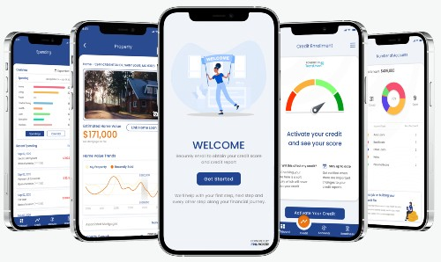

**Let [FinLocker] guide you to homeownership**

The [FinLocker] is our free personal financial management app where you can:

* Receive your free credit score and credit report monitoring from TransUnion
* Manage all your bank accounts, loans, and investments in one place
* See where you’re spending so you can start saving for your down payment and closing costs
* Create goals and budgets to save and pay down any debt
* Calculate a monthly mortgage payment based on your income

**Plus,** the app will let you know when you are eligible for a mortgage. You can also search for a home within your budget and start your mortgage application directly from the app!

**Enter this code at registration:** [consumer invitation code]

**Got 2 minutes? Claim your [FinLocker] now!**

[consumer-invitation-URL]

**Email: Day 5**

Subject Line: Monitoring your credit just got easier

**Receive your free credit score & credit report monitoring**

Hi [recipient-first-name]

Your credit score and credit report are two factors that will impact your eligibility to be offered good mortgage terms.

We want to help you to improve your eligibility for a mortgage, so we’re giving you [FinLocker], our free app that has all the tools and resources you’ll need to buy a home.

* Receive your free credit score and credit report monitoring from TransUnion
* Get notified when your credit score increases or decreases
* Track your payment history and use other tools to help build your credit
* Manage all your bank accounts, loans, and investments in one place
* Create budgets and track spending in real-time to save for your down payment and pay down any debt
* Use the home affordability calculator to receive a home budget and monthly mortgage payment based on your income

**Enter this code at registration:** [consumer invitation code]

**Claim your [FinLocker] now!**

[consumer-invitation-URL]

**Email: Day 10**

Subject Line: Learn how much home you can afford with our homebuyer app

**Qualifying for a mortgage might be easier than you think**

Hi [recipient-first-name]

Did you know that you can qualify for a home loan with much less than a 20% down payment, and you don’t need an excellent credit score?

To help you build credit, save for your down payment, and financially prepare to buy and own your home, we’d like to give you a free [FinLocker].

[FinLocker] is a secure personal financial management app that prepares you for homeownership and achieving other financial goals. The app provides tools and resources to build and monitor your credit, manage your financial accounts and debt, save your down payment and closing costs, and receive a homebuying budget based on your income.

Use our app to monitor your progress towards mortgage readiness in real-time, and begin your home search and mortgage application when you’re ready.

**[FinLocker] is the only app you need to manage your money and prepare for homeownership:**

**Enter this code at registration:** [consumer invitation code]

**Claim your [FinLocker] now!**

[consumer-invitation-URL]

**Email: Day 16**

Subject Line: Reap the financial benefits of owning your home

**Owning your home is a great way to build wealth**

Hi [recipient-first-name]

Did you know that the average homeowner’s net worth was over 40 times greater than that of a renter1?

Here are a few reasons why purchasing a home can be a smart financial decision.

1. **Build equity** – When you rent a home, your monthly payments go to your landlord. When you own a home, your monthly mortgage payments enable you to build equity over time, which increases your net worth. Home prices are currently rising faster than rents across the nation. As your home value increases, so does your home equity.
2. **Stable payments** – For the past few years, rent payments for a single-family home have increased 3-4% each year2. Buying a home with a fixed-rate mortgage will enable you to lock in your interest rate, so your monthly mortgage payment will remain the same for the duration of your mortgage term.
3. **Tax benefits** – Real estate property taxes, interest, and other origination fees may be deductible on your income taxes. A professional tax accountant can advise you on how to deduct these payments.

**Your free [FinLocker] will help you financially prepare to buy your home and start building equity.**

FinLocker is a secure financial assistant that prepares you for homeownership and to achieve other financial goals. The app provides tools and resources to build and monitor your credit, manage your financial accounts and debt, save your down payment, and establish positive financial habits.

**Enter this code at registration:** [consumer invitation code]

**Got 2 minutes? Get your free [FinLocker]!**

[consumer-invitation-URL]

1 [Survey of Consumer Finances](https://www.federalreserve.gov/publications/2020-bulletin-changes-in-us-family-finances-from-2016-to-2019.htm)

2 CoreLogic [Single-Family Rent Index](https://www.corelogic.com/blog/2020/9/us-single-family-rent-growth-stabilized-at-a-low-level.aspx)

**Email: Day 24**

Subject Line: Prepare for your mortgage with our [FinLocker] app

**Receive a free [FinLocker] to prepare for homeownership**

Hi [recipient-first-name]

The process of buying your first home may seem overwhelming, but it doesn’t have to be. Our team is here to support you throughout the entire home loan process.

To help you improve your eligibility for a mortgage, we'd like to give you a free [FinLocker] that has the tools to prepare for homeownership in one free app!

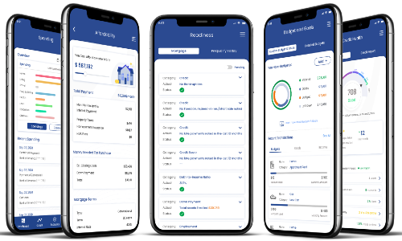

**[FinLocker] is a secure financial assistant that prepares you for homeownership and to achieve other financial goals.** The app provides tools and resources to build and monitor your credit, manage your financial accounts and debt, save your down payment, and establish positive financial habits.

The app has an interactive home affordability calculator that recommends a homebuying budget and monthly mortgage payment based on your income. You can compare Conventional, FHA, or VA loans and estimate how much you need to save and create trackable goals to save for your down payment and closing costs.

**The app contains a quick readiness assessment that will let you know when you’re financially ready to qualify for a mortgage.** When you’re ready, you can start your home search and mortgage application directly from the app. Your mortgage lender can also be contacted directly from the app to answer your questions..

**Enter this code at registration:** [consumer invitation code]

**Got 2 minutes? Get your free [FinLocker]!**

[consumer-invitation-URL]

Day 30

Subject Line: 5 Great things about owning your home

**Homeownership can improve your lifestyle**

Hi {{recipient.f_name}}

There are not just financial benefits to be gained by buying a home; there are lifestyle benefits, too.

**1 - Gain a Community** – Many neighborhoods have associations that will plan events and gatherings so you can get to know the people who live around you.

**2 - Provide Stability** – If you have children or want to start a family, owning your home can provide your family with stability as you can plan to stay put until you decide that the time is right for you to move.

**3 - Improved Health** – Studies show that overall well-being improves when a person moves from renting to owning a home. A steady home provides a family with higher self-esteem and lower levels of distress, and more positive mental health, which is associated with lower blood pressure.

**4 - Show Your Style** – Most landlords will not allow you to personalize the rental property by hanging pictures, painting walls, or retiling the backsplash. Buying a home gives you the flexibility to make modifications, so your home reflects your style. Plus, any improvements you make will contribute to the value of your home.

**5 - Get A Pet** – It is often difficult to find a rental property that will allow you to have a pet. And when they do, properties usually require a pet deposit. When buying your own home, you gain the freedom to own dogs, cats, birds, lizards, chickens, or any other type of animal you would like.

**We are committed to guiding you through the home-buying process.** **To help you financially prepare to buy and own your home, I’d like to give you a free [FinLocker].**

[FinLocker] is a secure financial assistant that prepares you for homeownership and to achieve other financial goals. The app provides tools and resources to build and monitor your credit, manage your financial accounts and debt, save your down payment, and establish positive financial habits.

**Enter this code at registration:** [consumer invitation code]

**Got 2 minutes? Get your free [FinLocker]!**

[consumer-invitation-URL]